AWS Task-2

Task Description:

Set up a VPC with an Internet gateway, create a public subnet with 256 IP addresses, a private subnet with 256 IP addresses, make a route table connecting the Internet gateway and the subnets, and launch a Linux EC2 instance by using the above VPC and public subnet.

VPC created :

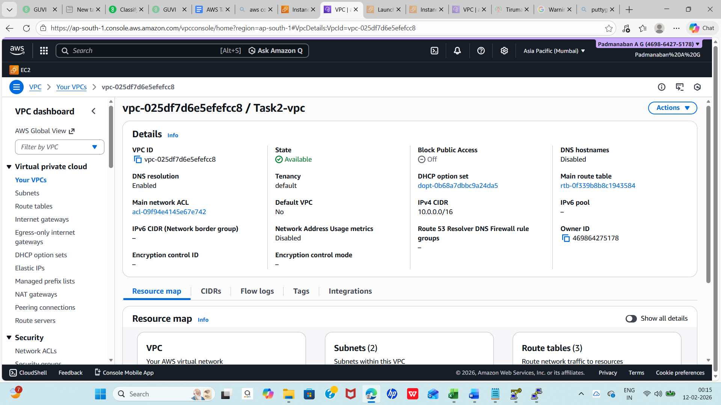

Public & Private Subnet created :

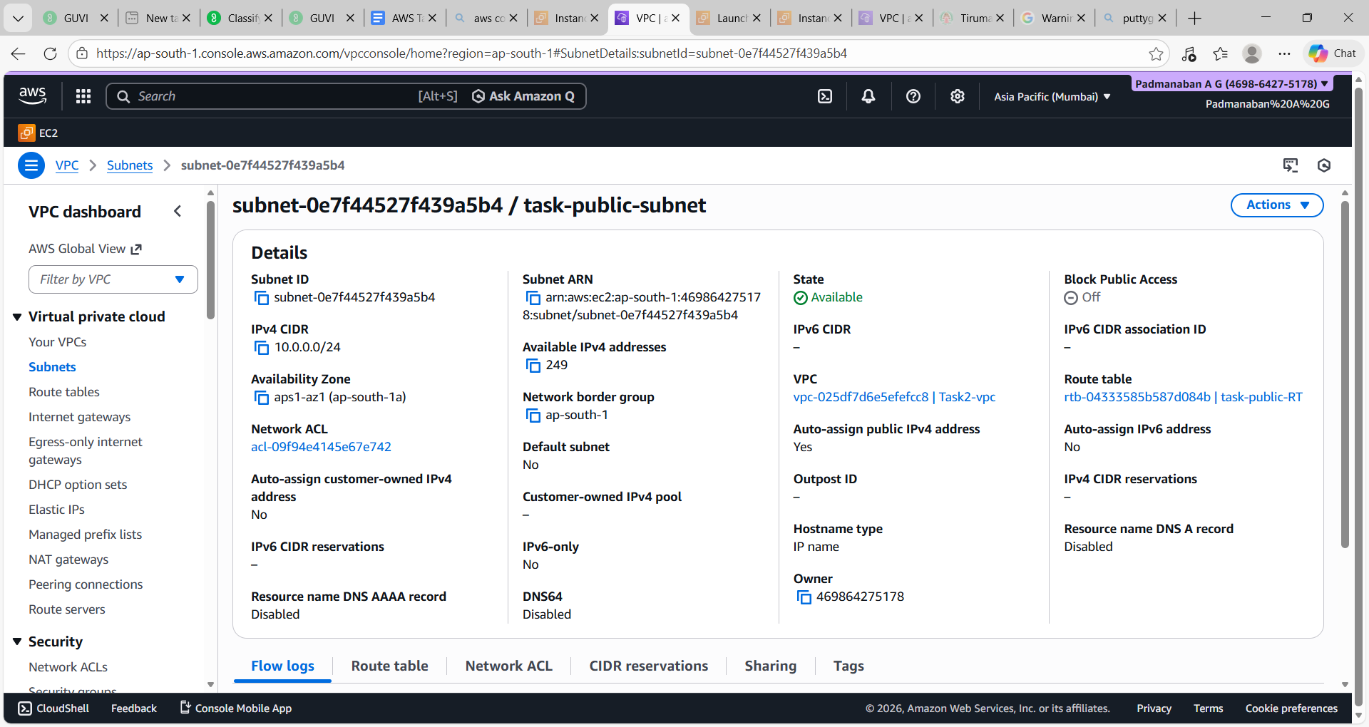

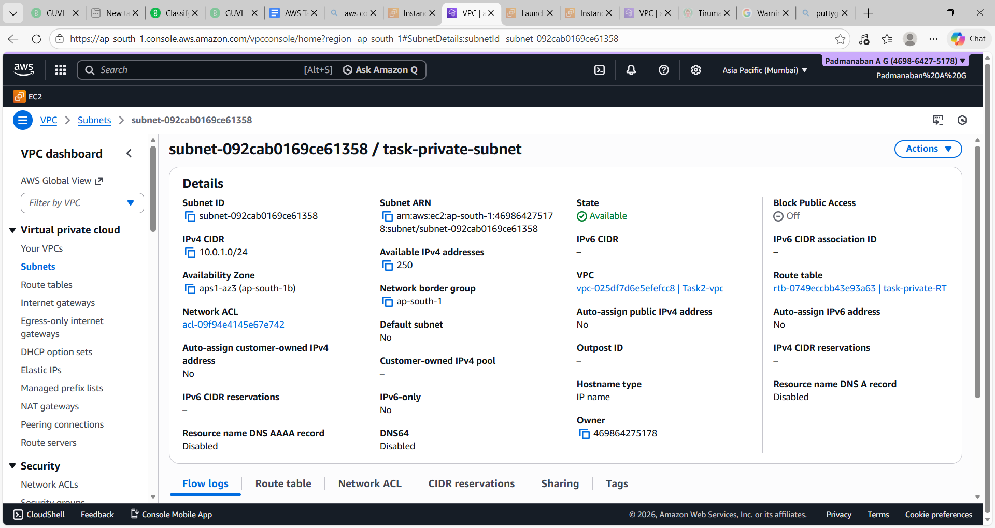

Internet Gateway created :
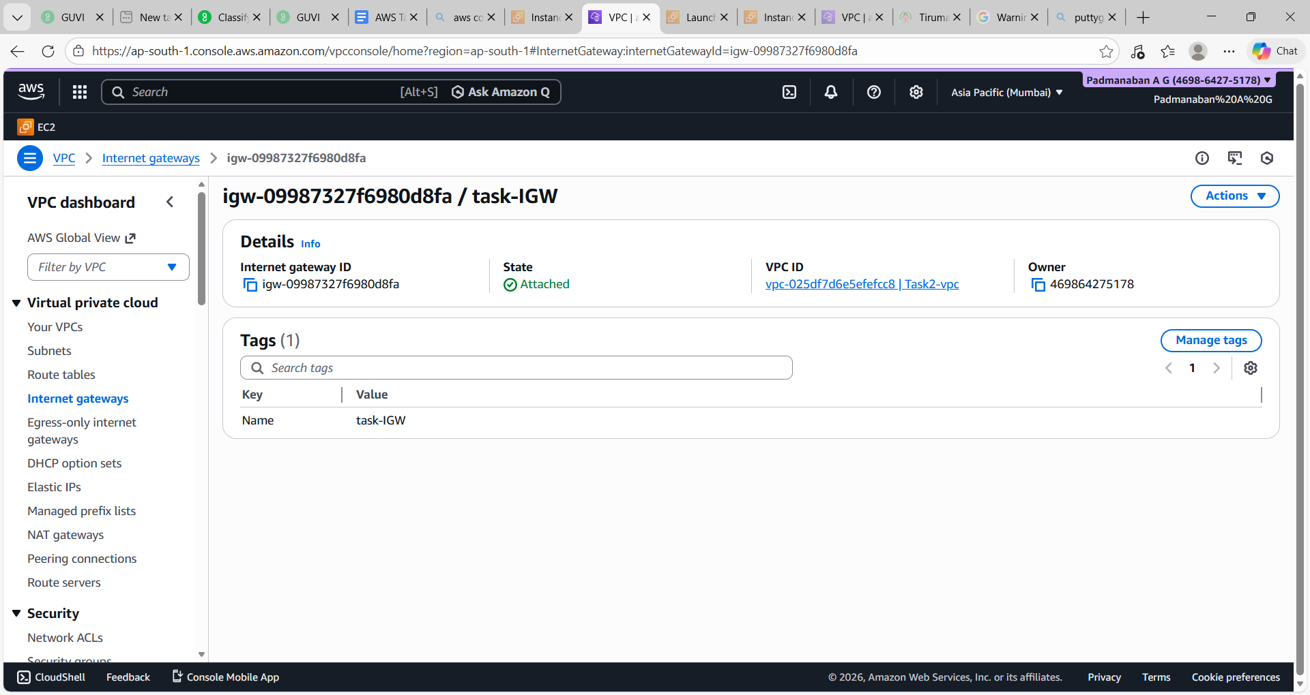

Created Public Route Table:

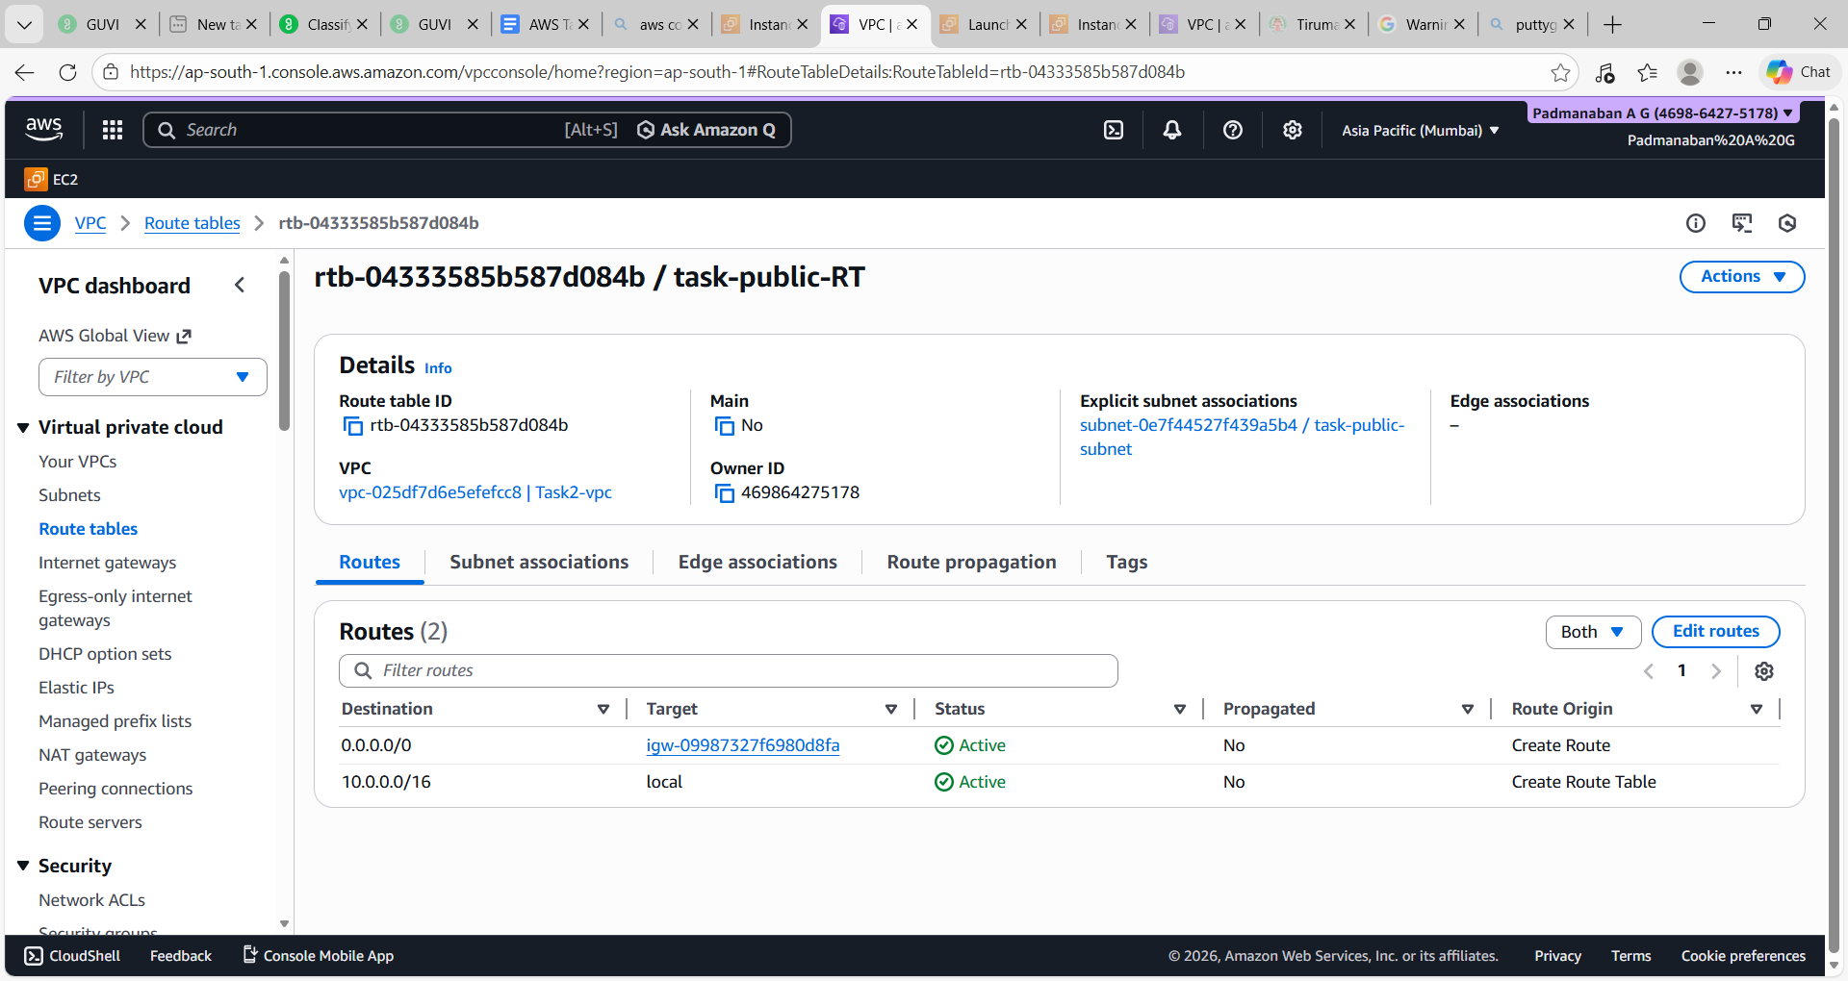

Created Private Route Table:

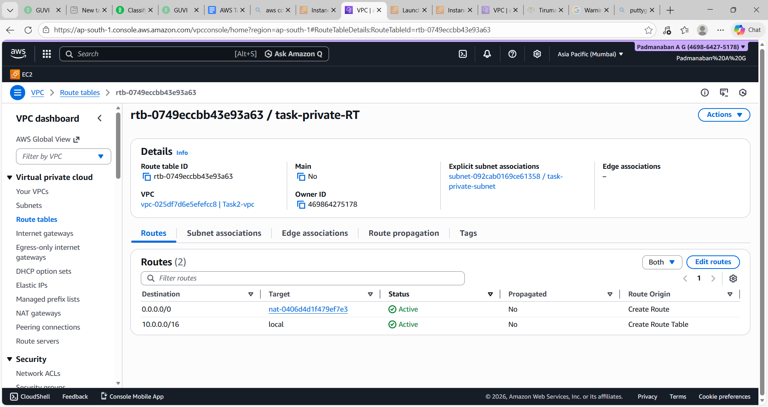

Created NAT gateway :

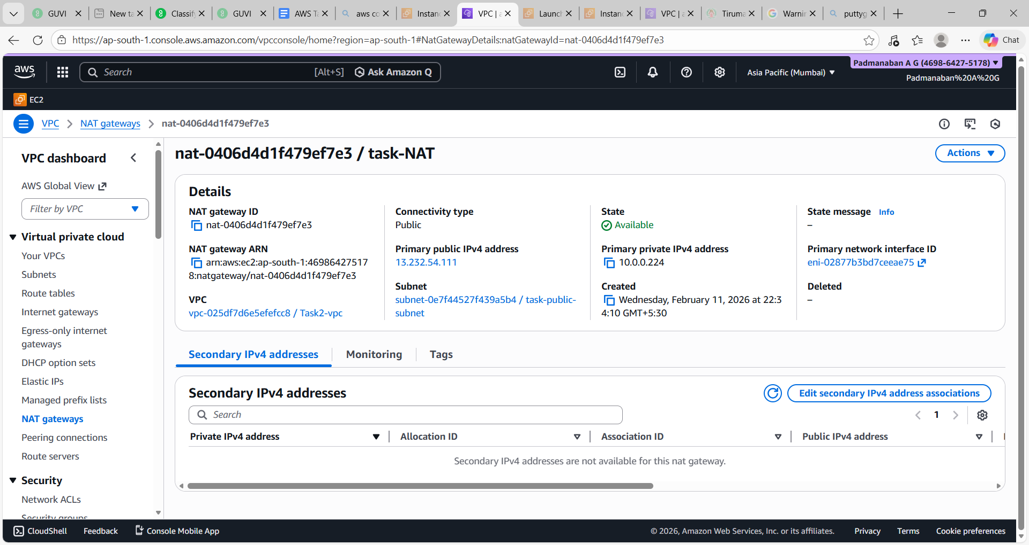

Created EC2:

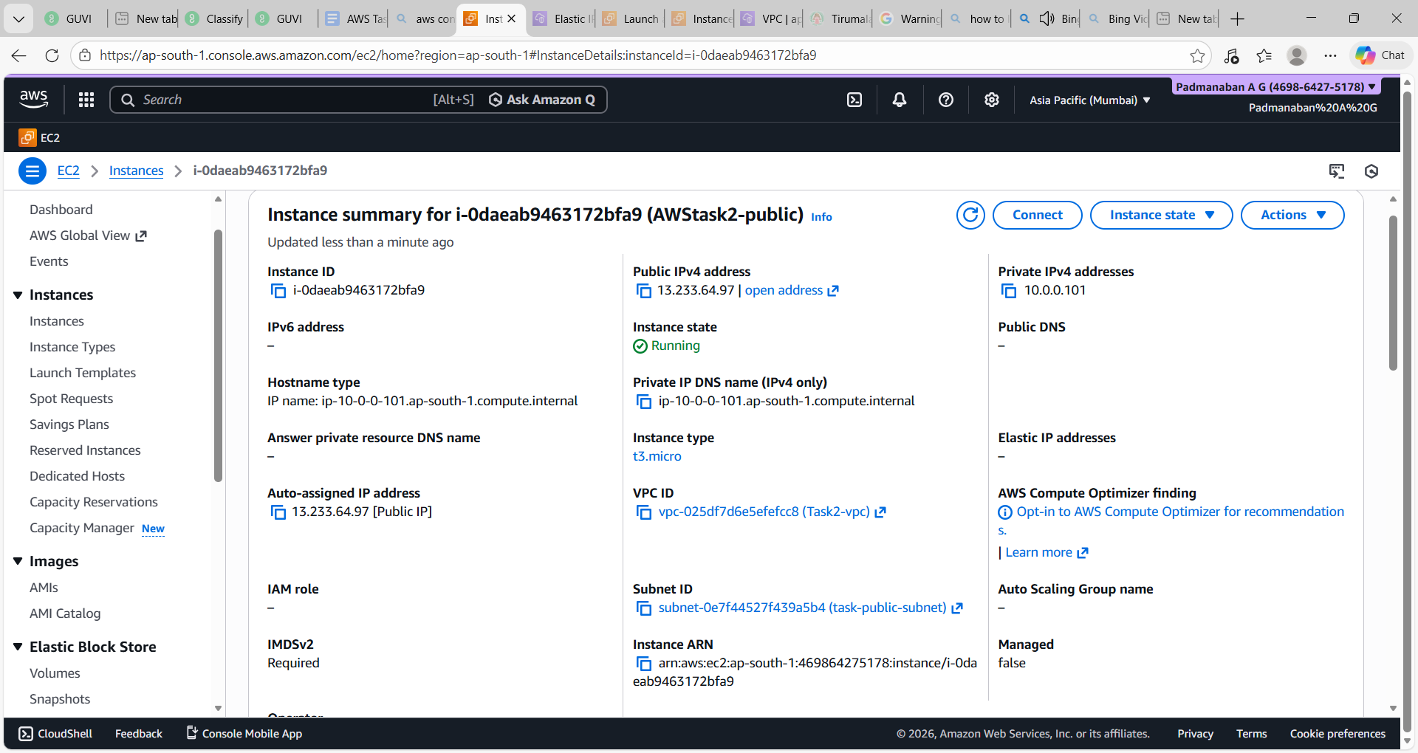

EC2 created and Connected via putty , uploaded key on PEM file

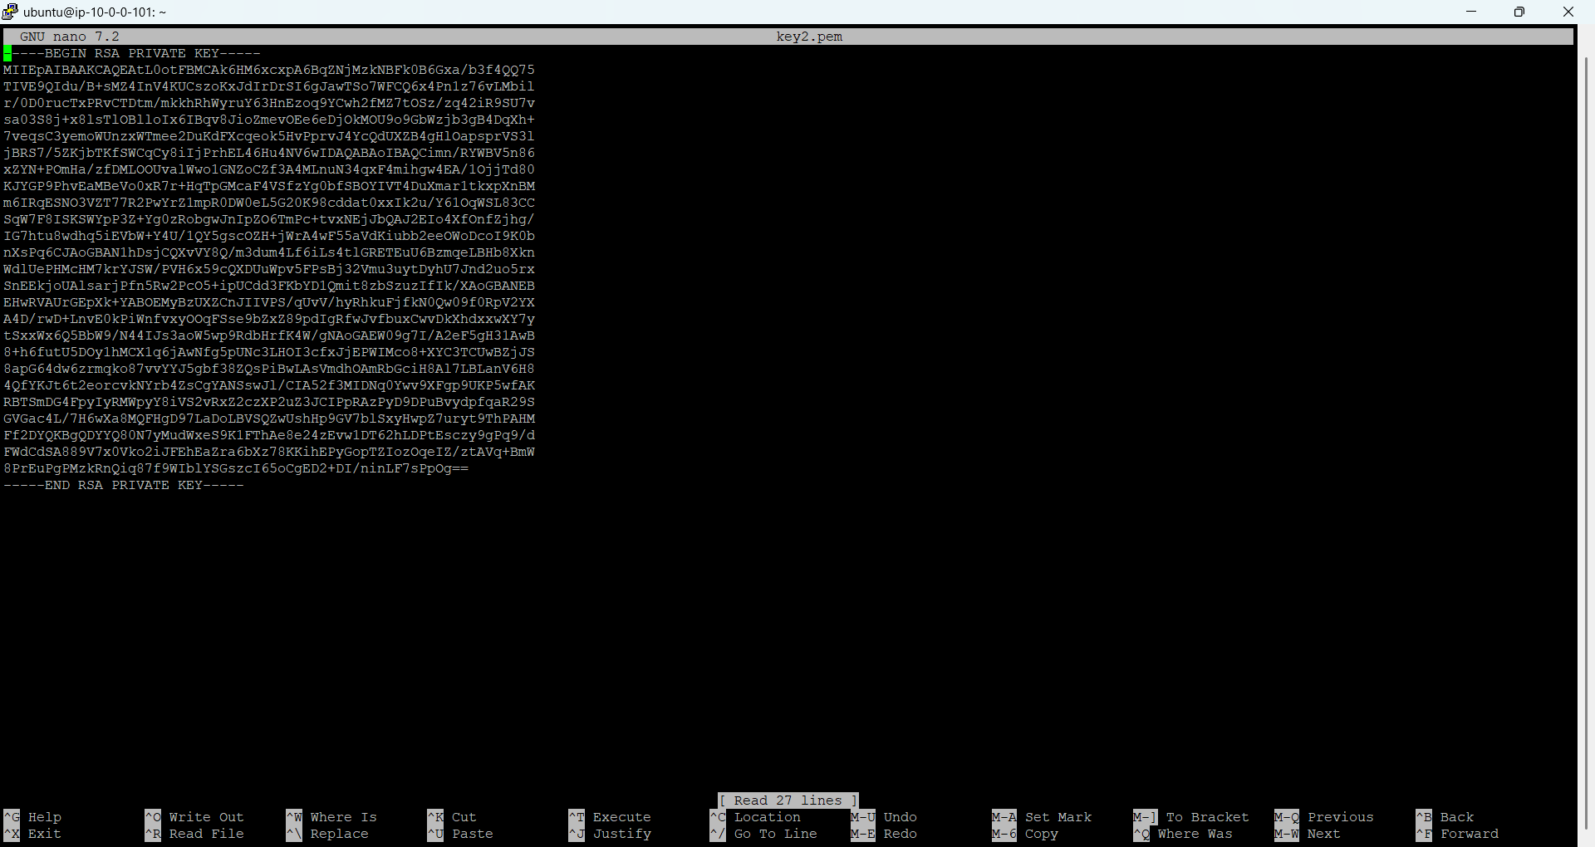

Modified access with command :
sudo chmod -R 600 key2.pem
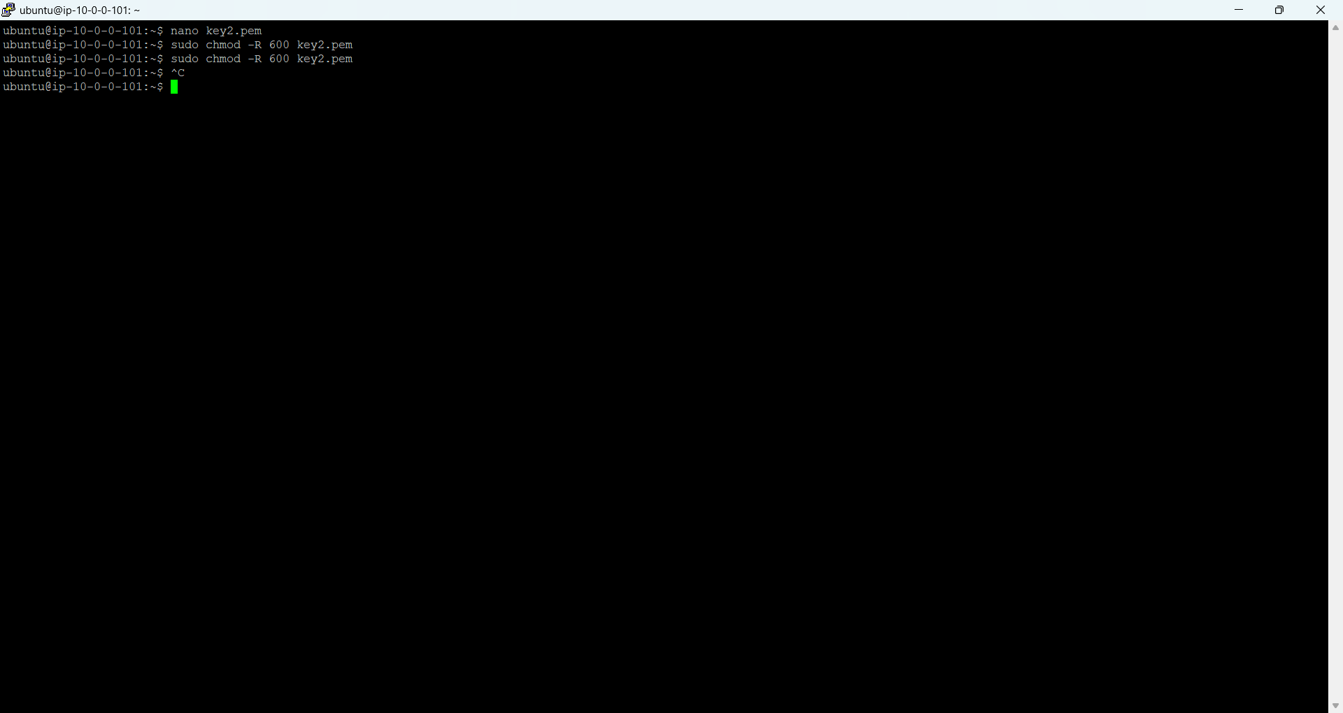

Connected EC2 via SSH

